**Artificial neural network-based temperature prediction of a 2d vertical pin fin system on horizontal base plate**

**Soumyadeep Dey**

**Abstract**

This study explored the application of artificial neural network (ANN) and machine learning in predicting the temperature distribution of a two vertical pin fin system. Building on the 2d numerical CFD based approach such as [reference], we used supervised machine learning to approximate the temperature field using spatial coordinates as inputs. Our data is derived from the simulation of the vertical fin in Ansys fluent to predict the temperature. The performance of the ANN model is evaluated by Mean Absolute Error and Relative Error. The low MAE proves the ANN model can be fast, reasonable and a good selection for iterative design and prediction.

**Keywords**

Machine Learning, Pin-Fin, Neural Networks, Vertical Fins, Temperature Prediction, CFD, Heat Transfer.

**1. Introduction**

Fin surfaces are widely used in heat dissipation processes. Though traditional research and development is going on to increase the efficiency of the fin, machine learning approach could be a good alternative to predict the heat transfer through the specific coordinates in 2d and 3d planes. Traditional systems rely on numerical analysis and finite volume analysis which are heavy computational tasks.

Recently data driven approaches like Artificial Neural Networks (ANNs) gained popularity in the thermal field. In this system, we train the model with some input parameters along with targeted output, then we predict the output with some unknown data.

In this study, we developed a ANN model which can take (x, y, BC) conditions as input parameters and temperature as targeted / output parameter.

**2. Methodology**

**2.1 Problem Statement**

* To develop an Artificial Neural Network that can predict the temperature distribution of a two fin 2d structure with same spatial coordinates (x, y) but with cases of different boundary condition. For example, training the model with (B.C. 320, 330, 340 degrees etc) and then predicting the temperature of (B.C. 350 and 370 degrees).
* A challenge was faced during processing and training the model, due to the highly overfitted and non-linear data.
* We have used Batch Normalization to reduce it and using Standard Scaler to reduce the noise and scale it within zero and one.

**2.2 Physical Model**

* + A 2d rectangular base plate with two vertical fins.
  + Steady state conditions were assumed.
  + Base and fins are at higher temperature then the surrounding temperature.

**2.3 Data Generation**

* + Data is obtained from CFD simulations in Ansys Software
  + Each data point includes (x, y) coordinates and their corresponding temperatures.

**2.4 Neural Network Architecture**

* + Input Layer – 3 neurons (x, y, BC)
  + Hidden Layer – 9 fully connected layers with Swish activation function
  + Output Layer – 1 neuron (Temperature)
  + Loss Function – Huber Loss
  + Optimizer - Adam
  + Framework – TensorFlow

**2.5 Training and Evaluation**

* + Data is split in 80% for training and 20% for testing the model.
  + We have calculated Mean Absolute Error and Relative Error.

**3. ANN Modelling**

The temperature prediction of a two vertical pin fin system was formulated as a supervised machine learning regression task. The spatial coordinates (x, y) along with boundary conditions (BC) were taken as input and temperature values T(x, y) were taken as the targeted variable.

The ANN was implemented using TensorFlow framework in python. A feedforward neural network with 10 hidden layers has been implemented, with 256-128-64-32-16 neurons in each layer respectively, along with swish activation function. The output layer is a single neuron with linear activation function.

The Adam optimizer was used with a learning rate of 0.001. The loss function used was Huber loss which is quadratic for small values and linear for large values, it is less sensitive to outliers and smoothens the curves for corner values. Training was performed with 30 epochs with early stopping and reducer LRO n plateau to avoid overfitting. The model was trained using GPU acceleration.

A total of (1947422, 3) data points were trained and validated on (486856, 3) data points. Batch normalization was applied to stabilize training and the data points was scaled using standard scaler to fit between 0 and 1.

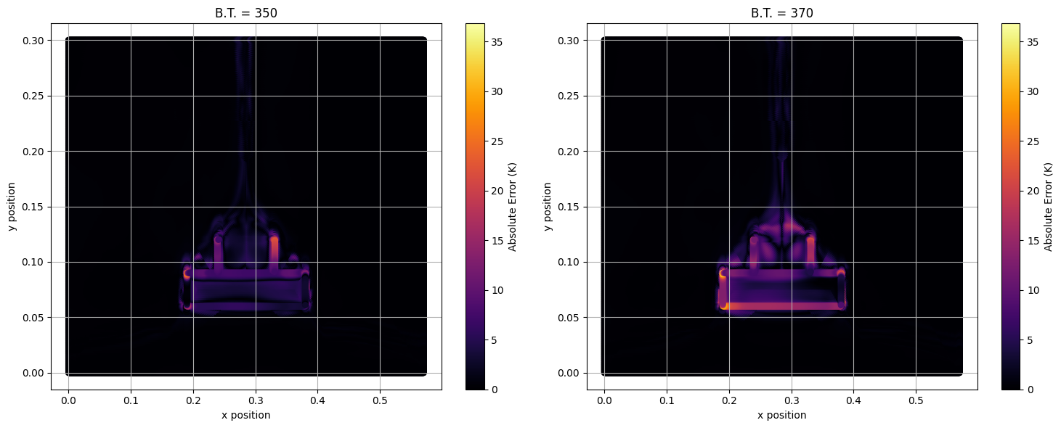The convergence of the model was seen through loss curves. Final MAE score came to be 0.4877 on the test set. The final prediction across corner points being the maximum error with ±25 K across the domain.

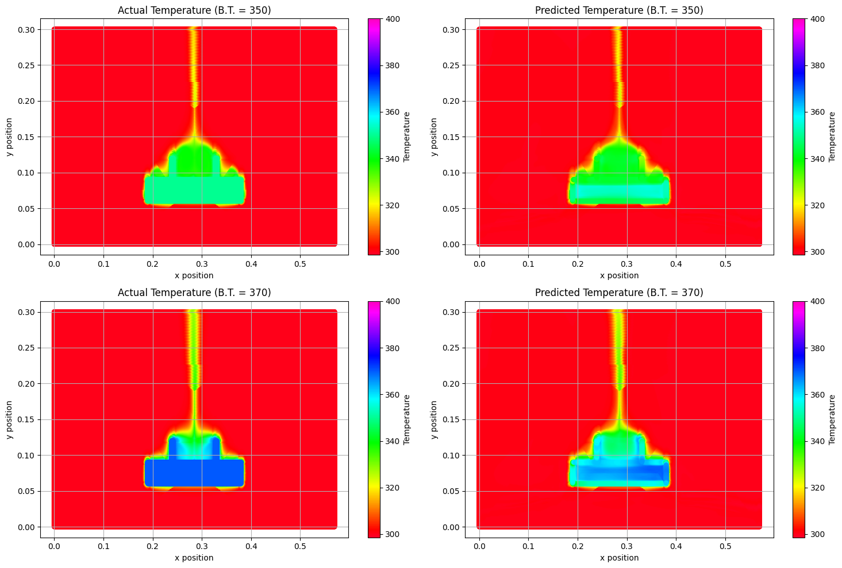

**4. Result**

The ANN predicted temperature contours show close resemblance to the simulation results obtained from CFD. In regions near the fin walls, where steep gradients in heat flux are observed, the model maintained reasonable accuracy. Figure X shows the predicted vs actual temperature contours, and Figure Y shows the scatter plot of predicted vs true temperatures.

Table 1: Performance Metrics of ANN

Metric Value

MAE 0.4877

Huber Loss 0.0181

Max Error +25 K

The model performs particularly well in regions of smooth thermal variation but shows minor deviation near sharp edges of fins where localized gradients exist. Despite this, the ANN offers a computationally inexpensive and rapid approximation technique for iterative design purposes.